//<EXP NO 1 >

<!DOCTYPE html>

<html lang="en">

<head>

    <meta charset="UTF-8">

    <meta http-equiv="X-UA-Compatible" content="IE=edge">

    <meta name="viewport" content="width=device-width, initial-scale=1.0">

    <title>Document</title>

</head>

<body>

    <div class="div">

        <h1>Area of Triangle</h1>

        <h3>Enter base of Triangle

            <input type="number" id="base">

        </h3>

        <h3>Enter height of Triangle

            <input type="number" id="height">

        </h3>

        <button onclick="Triangle()">Result is</button>

        <p id="result"></p>

    </div>

    <div class="div">

        <h1>Area of Rectangle</h1>

        <h3>Enter length of Rectangle

            <input type="number" id="length">

        </h3>

        <h3>Enter breadth of Rectangle

            <input type="number" id="breadth">

        </h3>

        <button onclick="Rectangle()">Result is</button>

        <p id="result1"></p>

    </div>

    <div class="div">

        <h1>Area of Circle</h1>

        <h3>Enter radius of Circle

            <input type="number" id="radius">

        </h3>

        <button onclick="Circle()">Result is</button>

        <p id="result2"></p>

    </div>

    <script src="script.js"></script>

</body>

</html>

function Triangle(){

    let bases = document.getElementById("base").value;

    let heights = document.getElementById("height").value;

    let area = 0.5 * bases*heights;

    document.getElementById("result").innerHTML=` Area of Triangle is ${area}`;

}

function Rectangle(){

    let lengths = document.getElementById("length").value;

let breadths = document.getElementById("breadth").value;

    let area1 =  lengths*breadths;

    document.getElementById("result1").innerHTML=` Area of Rectangle is ${area1}`;

}

function Circle(){

    let radius1 = document.getElementById("radius").value;

    let area = 3.14 * radius1 * radius1;

    document.getElementById("result2").innerHTML=` Area of Circle is ${area}`;

}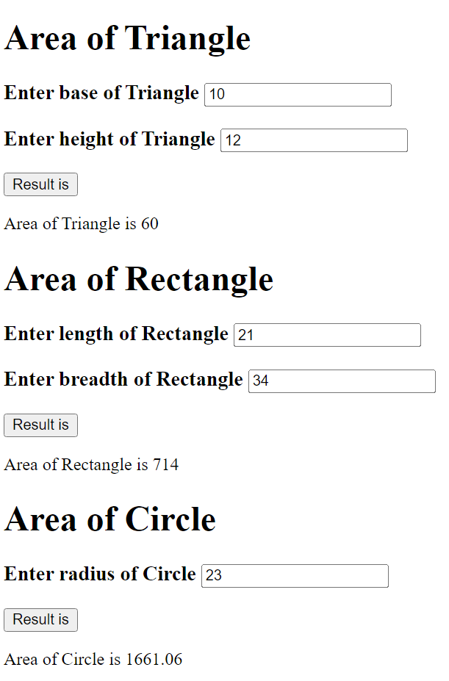

**OUTPUT:**